8th May 2025

Testing chamber sealing for leakage
- PTFE tape

Overview:
- A flexible membrane is used to connect the 3D-printed parts of the bioreactor chamber
- Establishing leak-proof connections between all parts of the assembled chamber is essential
- This is also important to maintain a sterile environment within the chamber, and potential points of leakage or entry of pathogens can be identified with a leak test

- In previous experiments,
  - Parafilm alone was insufficient to seal the chamber parts
  - Parafilm in combination with grease created a sufficient seal; however, the application of grease is not a feasible option
  - PTFE film applied on the outside of connecting pieces did not provide a good seal
- In this experiment,
  - PTFE film will be tested on the inside of connecting pieces

- The chamber will be tested for potential leakage by running water through the system under pressure

Procedure:
Leak test
- Apply the PTFE tape in-between connecting points (screwed parts, luer locks)
- Fill a large syringe with water and attach it to a luer lock on one end of the chamber
- Run the water through the system creating pressure to identify potential points of leakage

Results:
PTFE only:
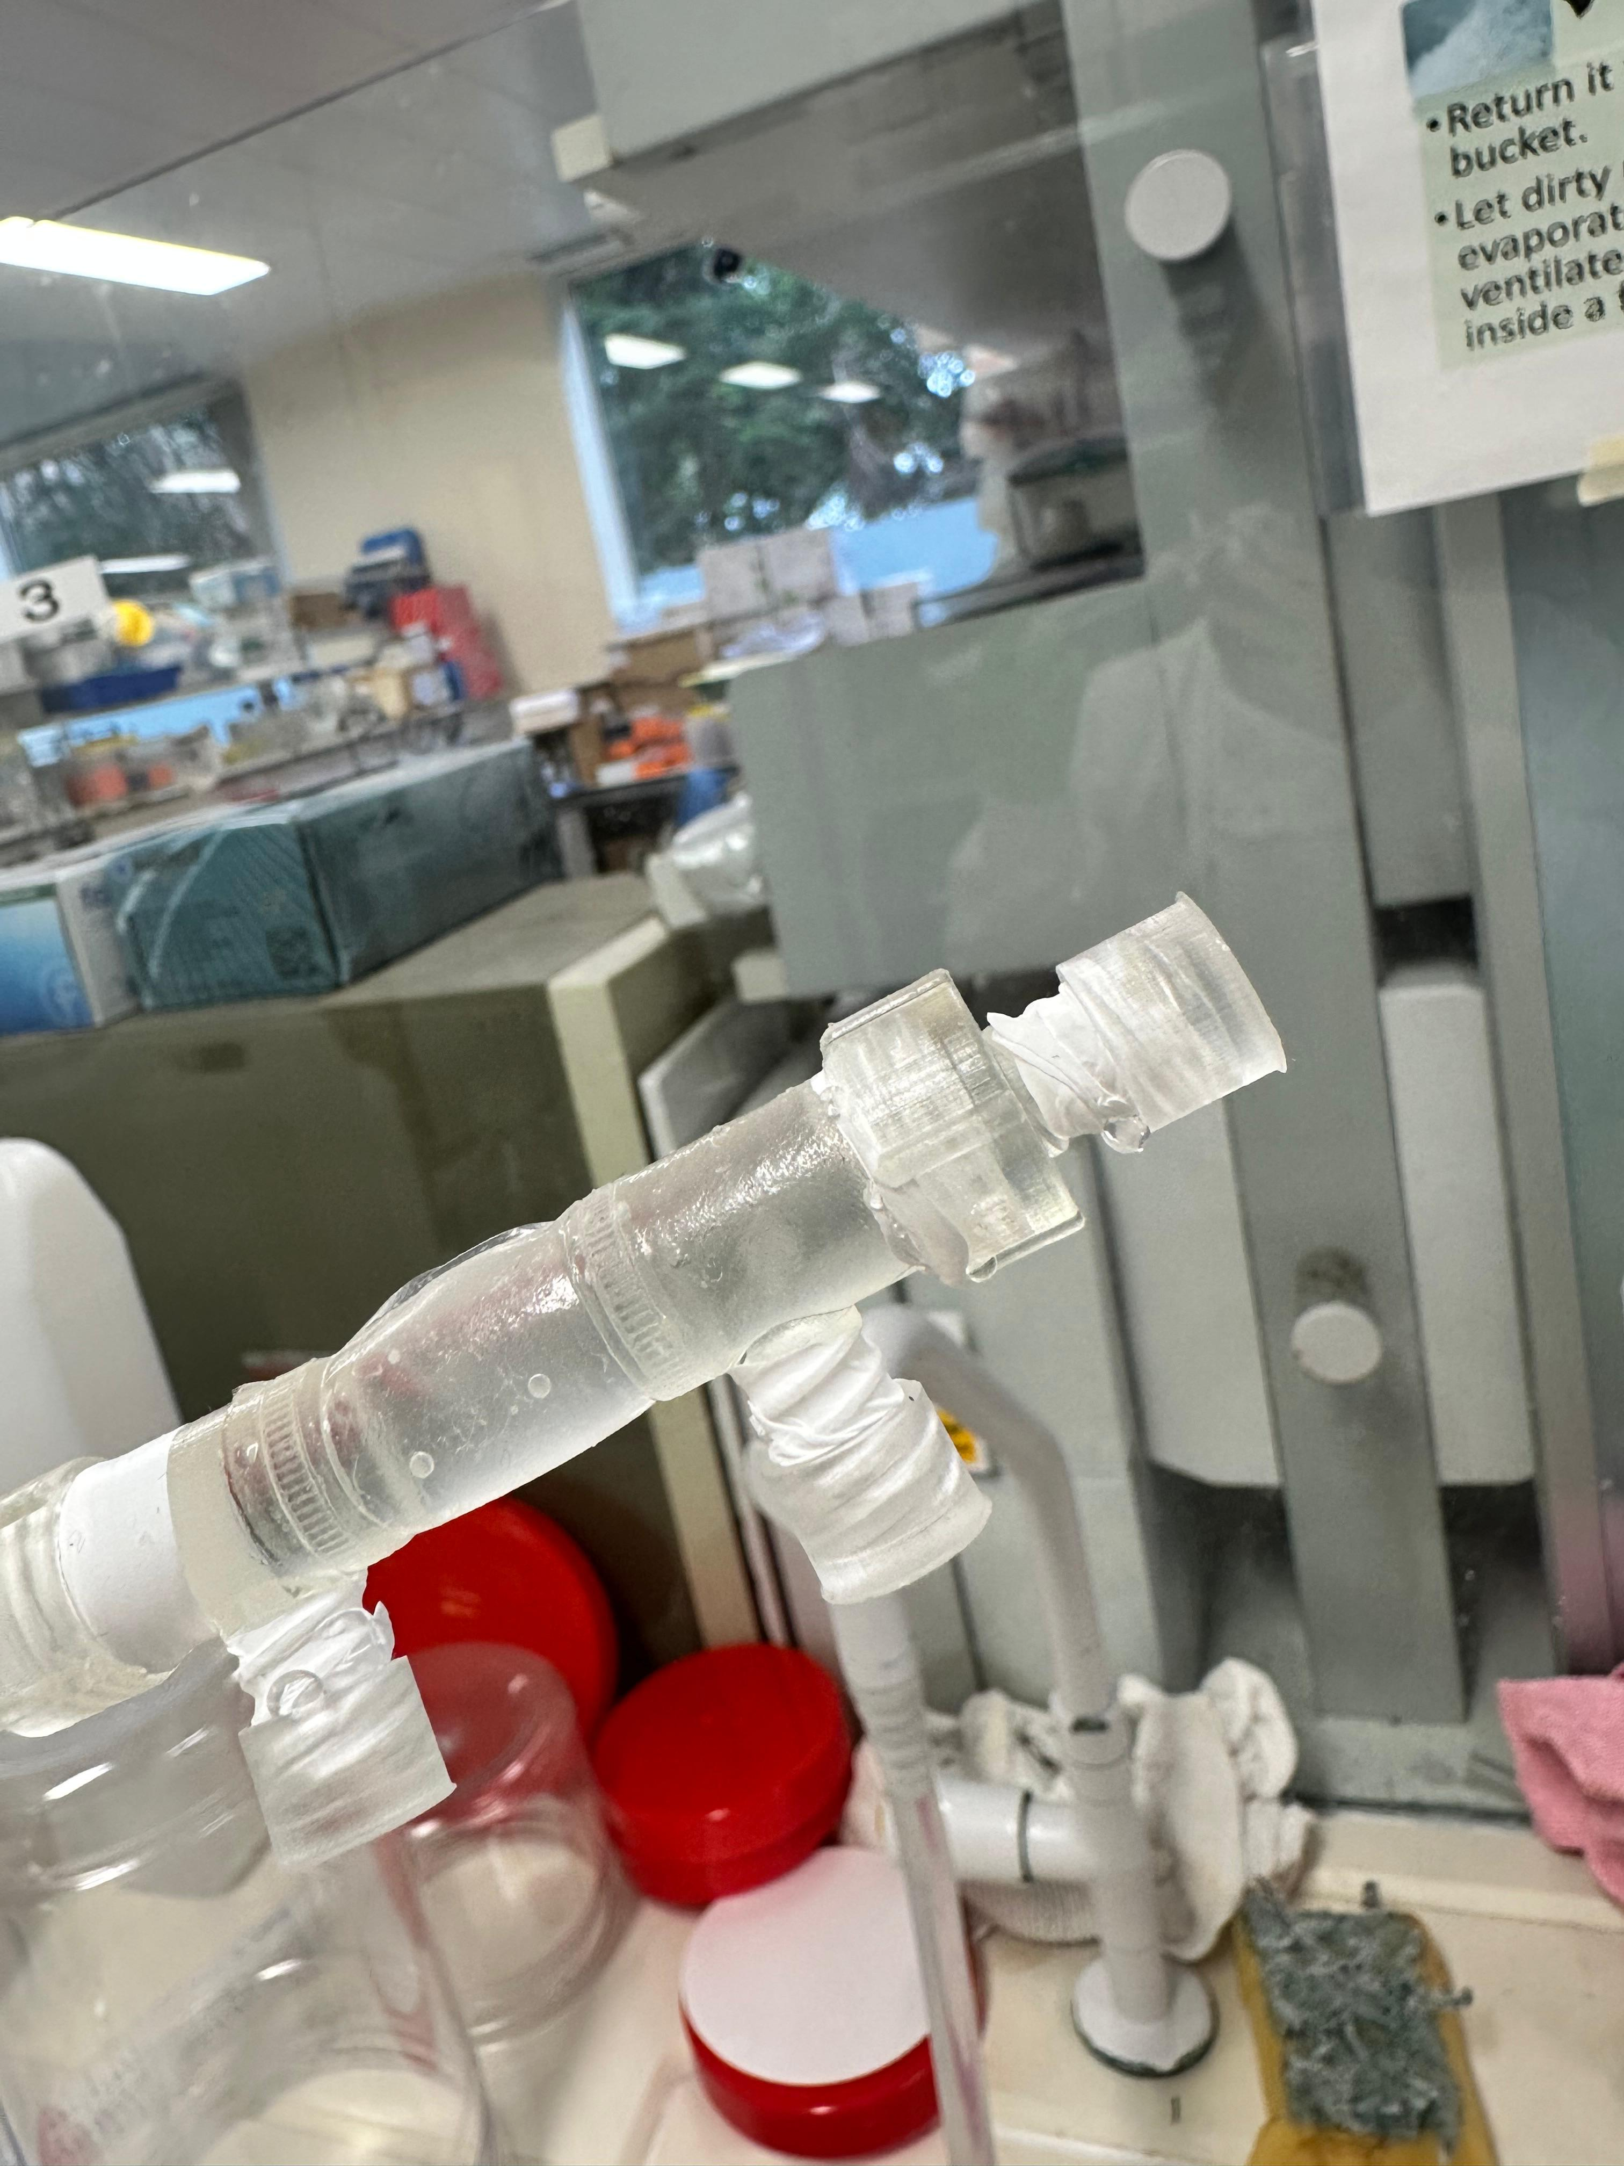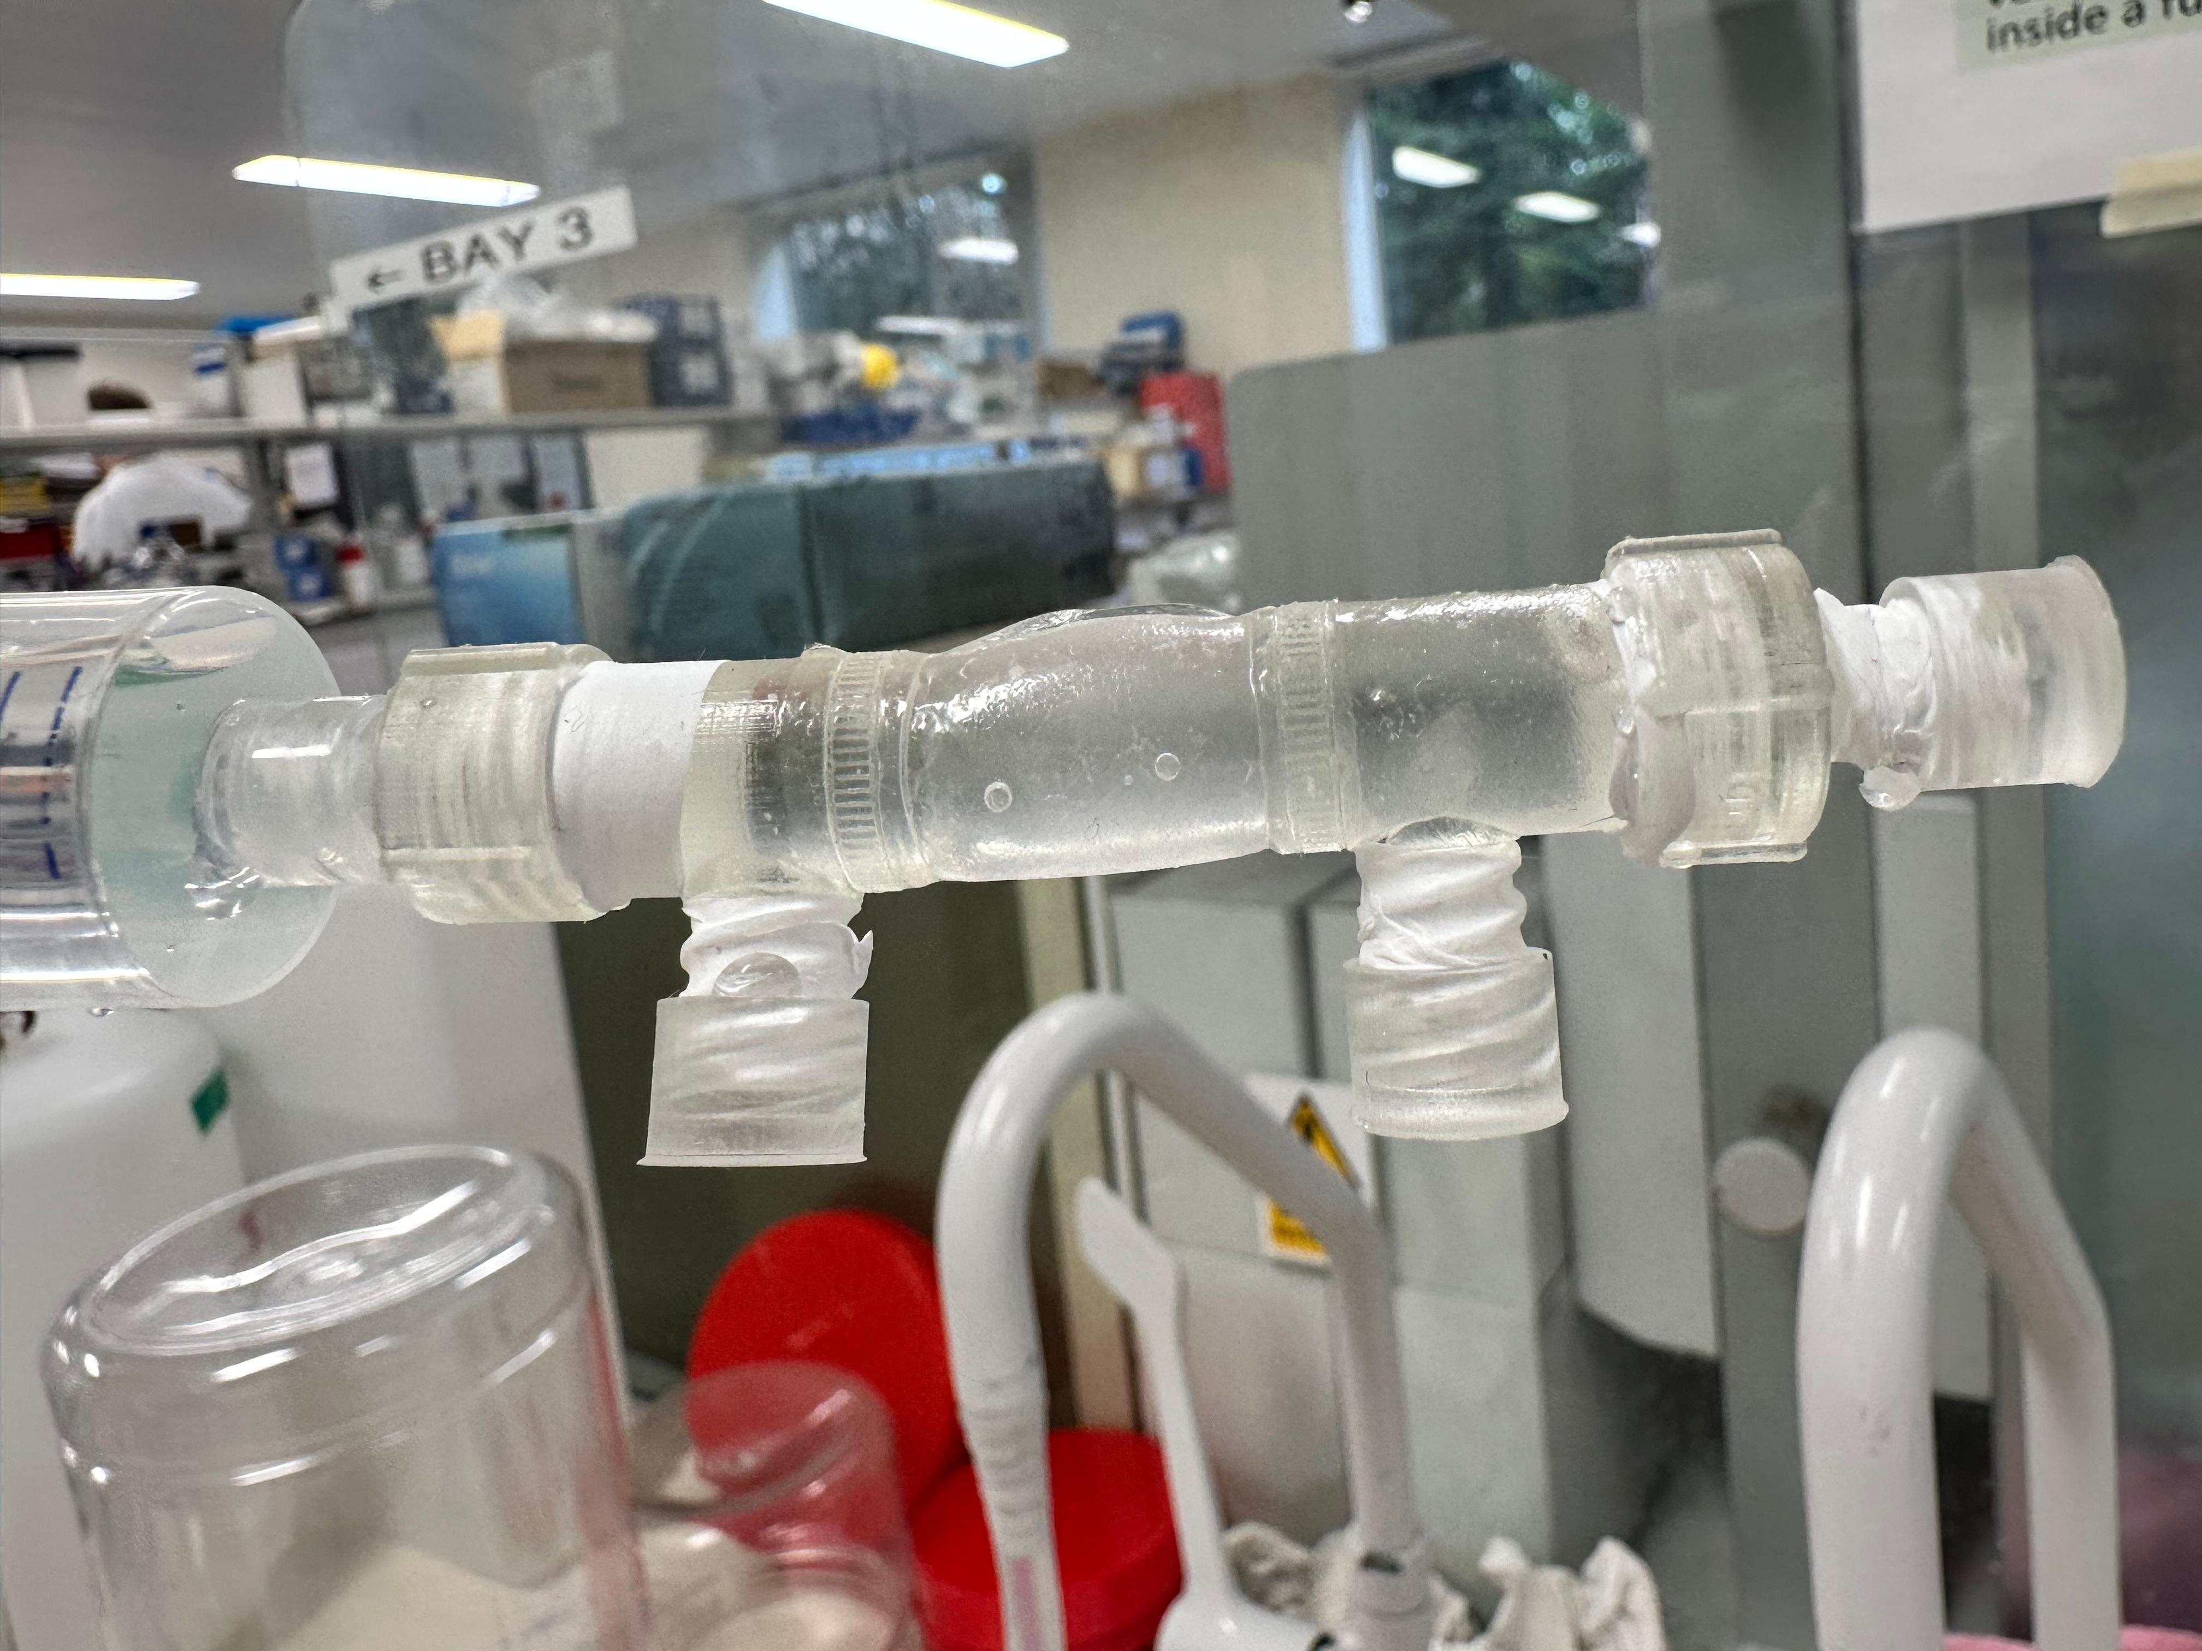
- Some leakage was observed despite the PTFE tape
PFTE plus parafilm:
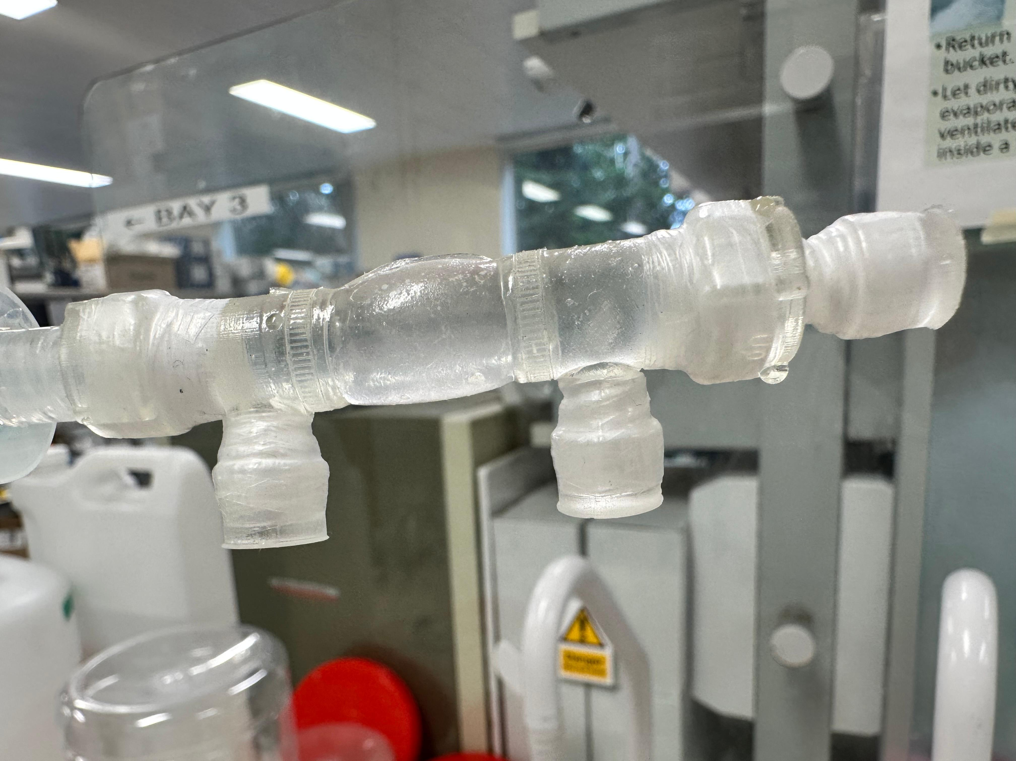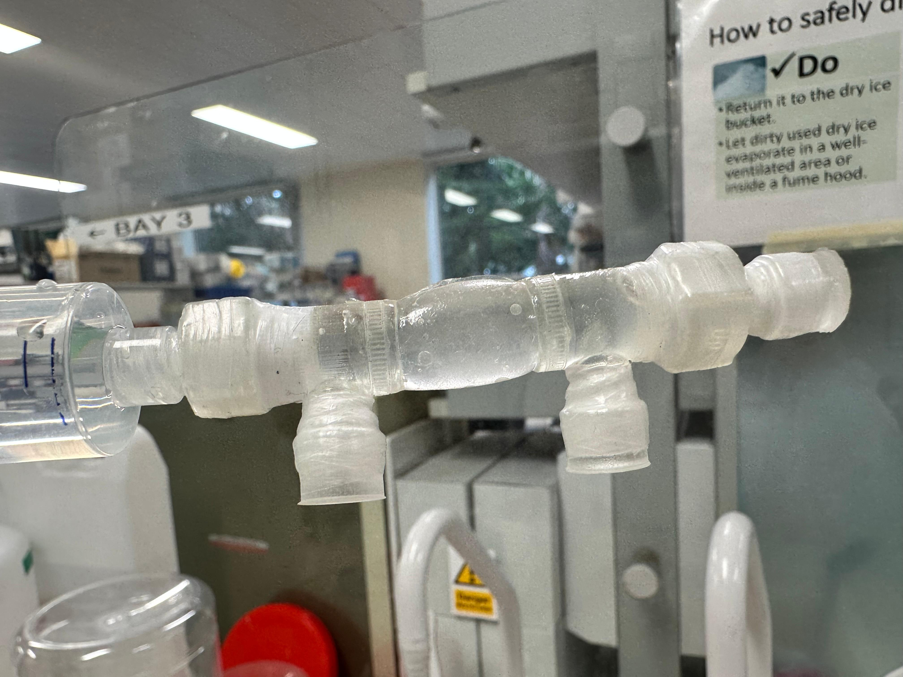
- With one and two layers of parafilm used in addition to the PTFE tape, leakage was still observed
- With three layers of parafilm in addition to the PTFE tape, the chamber appeared to be fully sealed, even under pressure

Next steps:
- The application of PTFE tape in addition to multiple layers of parafilm is rather unpractical
- Therefore, alternative options, such as glued on pieces, will be investigated

